PRESS RELEASE
COMMUNICATIONS AND MEDIA TEAM OF THE 43RD ASEAN SUMMIT 2023
No.110/SP/TKM-ASEAN2023/ENG/9/2023

Three Special Kitchens Behind 43rd ASEAN Summit Gala Dinner
Jakarta, 6 September 2023 – The Management of Gelora Bung Karno (GBK) Urban Forest owned by the Ministry of State Secretariat has the responsibility to ensure the quality of the banquet served at the Gala Dinner of the 43rd ASEAN Summit on Wednesday, 6 September 2023, at 19.30 Western Indonesian Time (WIB).
In addition to designation of stage location and table setting, the GBK Urban Forest management built three special kitchens for cooking different meals, starting from appetizer, main course, to dessert.
Head of Chef at Plataran City Forest, Reiyan Trisandra, made this statement to the Communications and Media Team of the 43rd ASEAN Summit 2023 on Thursday, 7 September 2023.
Firstly, Kitchen A is used specifically for preparing appetizers and desserts for VIP guests, such as members of the delegates participating in the ASEAN Summit. The kitchens were prepared in just four days.
And then there is Kitchen B which is used to prepare the main course for VIP and VVIP guests. Lastly, Kitchen C, which is used to prepare appetizers and desserts for VVIP guests who are Heads of State/Government [and their spouses].
All the ingredients have been provided by the organizers. All menus that will be served have been adjusted to the taste of the gala dinner participants. The kitchen staff involved must also follow various requests from each delegates’ protocol officers regarding the dietary restrictions of their Leaders.
"Some leaders don’t eat red meat, and some don't like salty food, or oily food. As for dessert, some ask for no sugar dessert and there‘s many other special requests. Of course, the kitchen must fulfill all of that," said Reiyan.
Apart from that, he continued, they also prepared white ceramic plates with the logo of the Garuda bird on one side along with gold cutleries. The dining table setting is also an important part of the gala dinner. There are dozens of round tables with a diameter of 1.6 meters, each of which is surrounded by eight iron chairs.

Dozens of Professional Chefs Involved
A number of well-known professional chefs were also involved. Judge of the famous cooking competition MasterChef Indonesia, Celebrity chef Arnold Poernomo was appointed as the executive chef for the event
Arnold Poernomo, known as Chef Arnold, who was born on 18 August 1988, prepared a menu with the theme “Nusantara the Forest” to be served to VIP and VVIP guests participating in the 43rd ASEAN Summit 2023.
Chef Arnold was assisted by a Gala Dinner Head Chef, chef Hans Christian, a prominent chef and owner of a well-known restaurant in Jakarta.
They are assisted by around 40 professional chefs such as Degan Septoadji and winner of Masterchef Indonesia Session 9, Cheryl Gunawan. In addition, there are several young and creative chefs such as Anita Susanto, Kesia Putri, Jenny Kinarti, Kresnan Anugerah Iqbal, Freddie Salim, Rully Mandala, Jackson Lee, Hans Kristian, Daniel Edward, Budi Cahyadi, and Ardika D. Tjandra.
"This is a collaboration between young and old chefs. Some of them also helped prepare dishes for the gala dinner of the 42nd ASEAN Summit 2023 in Labuan Bajo, 9-11 May 2023. The theme of our menu is Nusantara the Forest and as the request that the foods served must be luxurious, magnificent, delicious," said Arnold.
He said the ASEAN Summit is a stage for young chefs to show their skills to cook various Indonesian dishes to be served to the invited guests at this banquet tonight.
Arnold added, they were assisted by nearly 100 assistant chefs, most of them are students majoring in culinary arts from a number of tourism colleges in Jakarta and its surroundings.
Meanwhile, Chef Degan explained, the dinner served a menu of Indonesian dishes, the taste of which had been adapted to the taste of the invited guests.
"We want to show the gala dinner participants that Indonesian cuisine has gone international and can be suitable to everyone’s taste. We serve the foods in attractive plating, we combine with cooking techniques of the international standard. We want the menus served to go global," he said. (Anton Setiawan/TR)
***
For more information, please contact:
Director General of Public Information and Communications of the Ministry of Communications and Informatics – Usman Kansong (0816785320).
Get more information at http://asean2023.id, https://infopublik.id/kategori/asean-2023, and https://indonesia.go.id/kategori/ragam-asean-2023
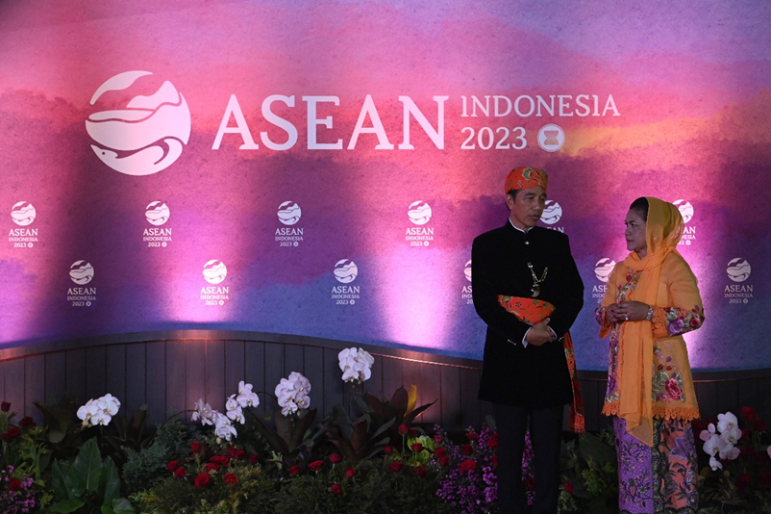
President Joko Widodo and First Lady Iriana Joko Widodo attend the 43rd ASEAN Summit Gala Dinner at Plataran City Forest, GBK Complex, Senayan, Jakarta, Wednesday, 6 September 2023. 2023 ASEAN Summit Media Center/Aditya Pradana Putra/aww.

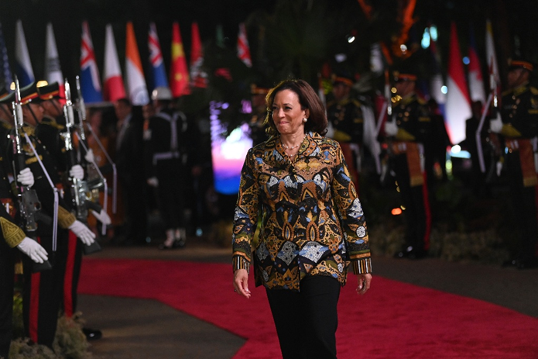

United States’ Vice President Kamala Harris attends the Gala Dinner of the 43rd ASEAN Summit at Plataran City Forest, GBK Complex, Senayan, Jakarta, Wednesday, 6 September 2023. 2023 ASEAN Summit Media Center/Aditya Pradana Putra/aww.

